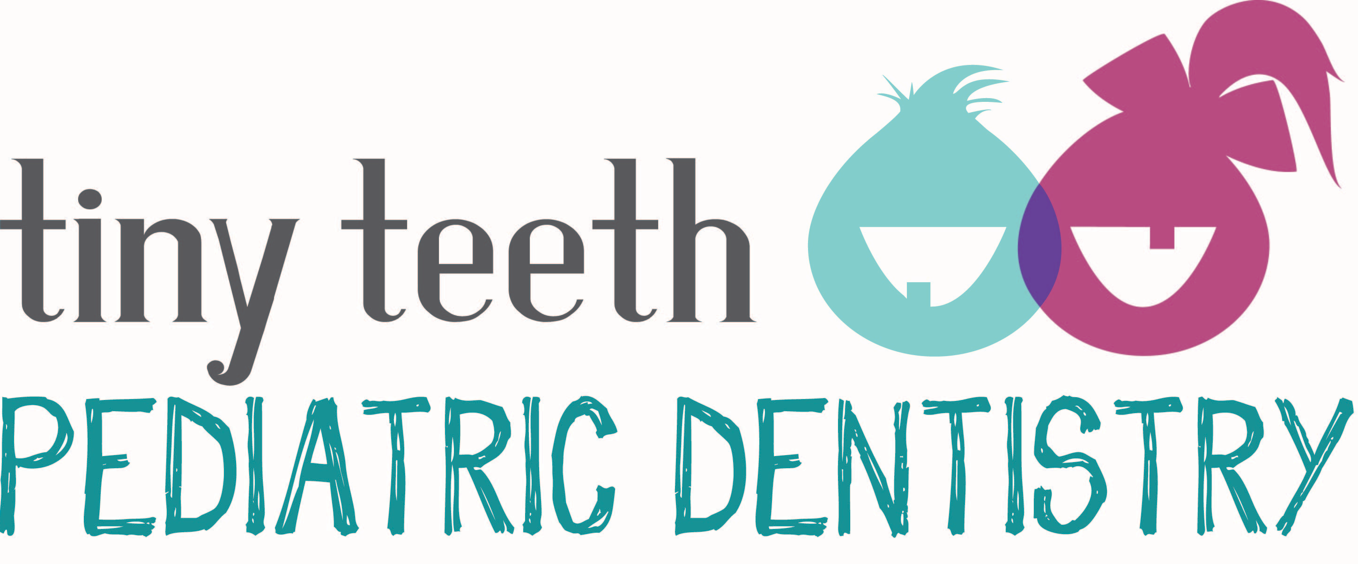
OFFICE POLICY AND CONSENT FORM
Please remember that we are here to serve you in a comfortable and professional atmosphere. Our goal is to provide you with the very best quality of dental care.
INSURANCE AND PAYMENT POLICIES
- FEES FOR SERVICE AT OUR OFFICE WILL BE REQUESTED AT THE TIME OF YOUR VISIT. For treatment involving fees above $500.00, special financial arrangements may be discussed with our financial coordinator or office administrator.
- For patients with Dental Insurance:
Your insurance is a contract between you, your employer, and the insurance company. We are not a party to that contract.
We will file your claim for you at no charge; however, we ask that your deductibles and your estimated portions (20%-60%) be paid as services are rendered. Although we gladly file dental insurance claims as a courtesy to you, any and all account balances are ultimately your responsibility.
Not all services are a covered benefit in all contracts. Some insurance companies arbitrarily select certain services they will not cover.
All insurance benefits are assigned to Tiny Teeth Pediatric Dentistry, unless services are paid in full the day of treatment.
- For your convenience, we accept VISA, MasterCard, Discover and Care Credit as well as checks and cash.
OFFICE POLICIES
- Your appointment time is set aside especially for you. We ask for courtesy to Dr. Anya Preece and to other patients that you keep your scheduled appointments. If you must change or miss an appointment, we require a 24-hour notice. Cancellations, last minute rescheduling or failure to show will result in a broken appointment charge of $50.00, or no reappointment. If more than one family member is scheduled & fails to make their appointment a $50 cancellation fee will be assessed for the first individual and $50 for each family member thereafter. This policy is strictly enforced due to our high volume of patients.
- Our office will provide confirmation calls and postcards to you. We ask that if we are unable to reach you, that you please contact us as soon as possible to confirm you appointment. Failure to do so may result in your appointment needing to be rescheduled.
- We realize that many families are in a state of change. The policy in our office is that the parent who requests treatment for a child is responsible to us for all fees incurred.
- We will be fair in working out special finances with you, but please also be fair to us with your commitments. A 1.5% finance charge will be assessed monthly on all overdue balances.
CONSENT
I have read and understand all the above information. I authorize Dr. Anya Preece to perform those diagnostic and treatment procedures, including local anesthesia and sedation, deemed necessary. If my child has any change in his/her health or change in his/her medication, I will inform Dr. Anya Preece at the next appointment. For insured patients, my signature below authorizes assignment of insurance benefits to Tiny Teeth Pediatric Dentistry and authorizes the release of dental records to my insurance company.
Date Signature (Patient, Parent or Guardian)

